Arduino Lesson 6
Push Button
I/O means INPUT interface and OUTPUT interface，so far the
LED experiment we designed just use the I/O output function
of Arduino. This experiment we will try to use the input function(i.e read the value from external device).
We use a push button and a led light to make an experiment use both input and output to let you know more about I/O.
- Parts Required
Push button x 1
Red 5mm LED x 1
220ΩResistor x 1
10KΩResistor x 1
Breadboard x 1
Jumper wires x 1 Bundle
- Connect-it-up
Access the button to digital interface #7, red led light to
#11.(I/O interface #0-#13 on Arduino all can be used to connect
the button and led,but try NOT to use #0 and #1 as they are multiuse interfaces, also the serial communication port. So keep them available to avoid any extra un-plug operation during experiment).

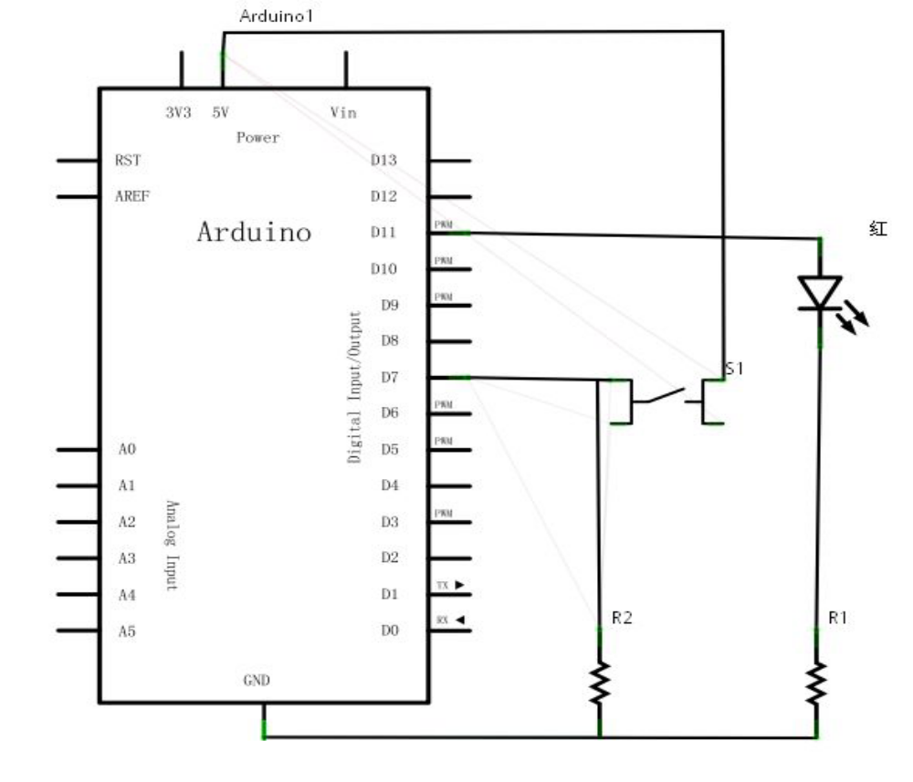
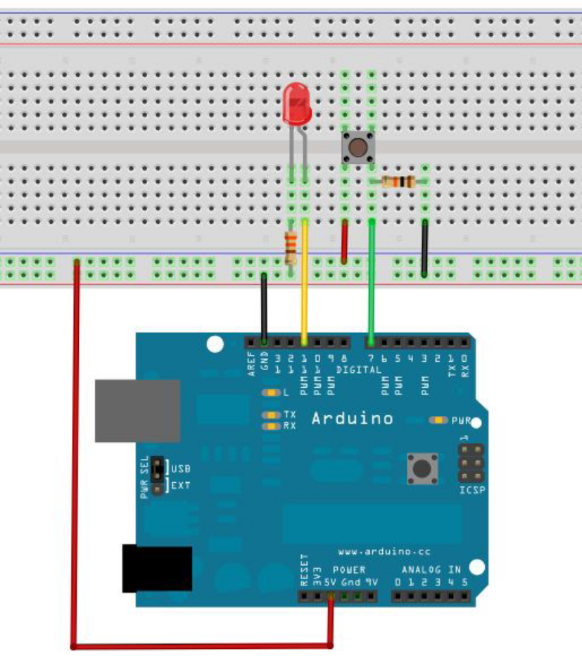
Now we begin to program to lighten the led when button pushed.
This one just add one more condition determine sentence (if
sentence)than the previous lessons. Arduino program base on C
language, so sentence from C can be used in Arduino, like while,
switch etc.
The below demo is a simple if sentence.
We can know that the #7 interface value read high level when
button is pushed according to the wiring.At the meantime, we
will turn on the light when #11 interface output high level.
In the program, we determine #7 interface is low level, if
it was then also need to make #11 as low level too.
- Program for reference
int ledpin=11;//define digital interface #11
int inpin=7;// define digital interface #7
int val;//define variable val
void setup()
{
pinMode(ledpin,OUTPUT);//define led interface as output
pinMode(inpin,INPUT);//define button interface as input
}
void loop()
{
val=digitalRead(inpin);//read digital interface #7 and assign
the level value to val
if(val==LOW)//test if the button been pushed,if did then
light on
{ digitalWrite(ledpin,LOW);}
else
{ digitalWrite(ledpin,HIGH);}
}
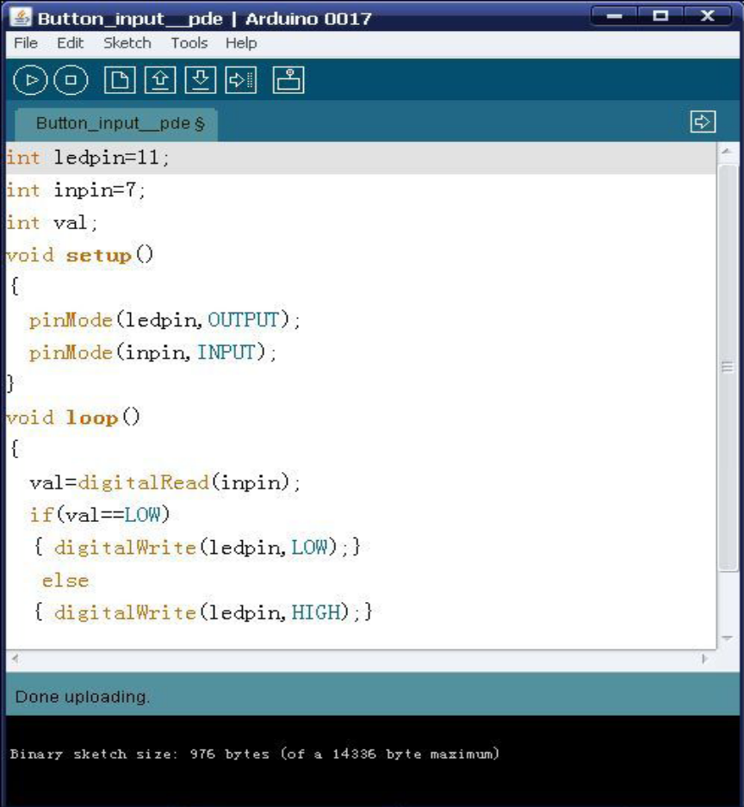
Download the program and your experiment is finish.You can
find this type of application very widely use in daily life.For
example, when you push your cellphone’s main button and
backlight is on. The next one we are going to make another common
one—Responder.

